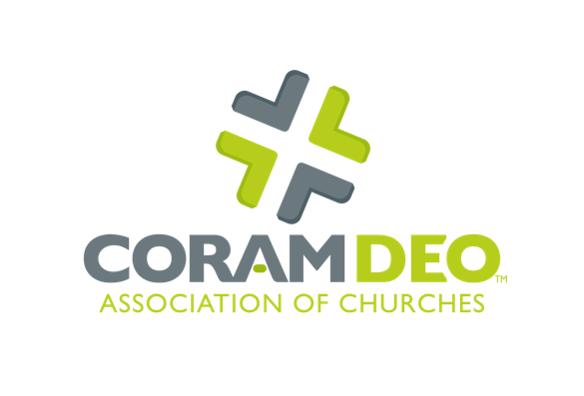
Pastoral Equipping /
Multiplication Leader Application Form
personal / family information
Today’s Date
Name (First, Middle Initial, Last)
Address (Street, City, State, Zip)
Email
Primary Phone
Date of Birth
Marital Status
Date of Marriage
Spouse’s Name
Number of Children
Names and Ages of Children
Name of Home Church or
Ministry Organization
Address of Home Church
Phone Number of Home Church
Name of Classis or Presbytery (if any)

education, work and ministry experience
Name of high school
and years attended
Name of college, degree
earned and years attended
Graduate school, degree
earned and years attended
Have you engaged any other conferences, seminars or training for ministry? If so, list all.
List all employment since high school with a brief description of job responsibilities
List all church and/or ministry experiences (volunteer and paid). Include ministry position, church, start date, end date, and description of responsibilities for all positions

Ministry calling and giftedness
Write a brief autobiography of significant events in your life and a description of how you came to know Christ and where that decision has led you. (You can type in the form or attach a separate sheet, if necessary.)
What have been some of the writers, Christian leaders, or mentors that have most influenced your spiritual journey, and in what way?
What natural and spiritual gifts has God given you?
Describe your motivation, vision, and call to become a ministry leader, commissioned pastor or multiplication leader with Coram Deo Association of Churches.
Are you willing to be mentored? (Mentoring entails a monthly relationship of accountability for call, character and competency growth in ministry.)
Are you committed to demonstrating the character of Christ that is necessary for Christian leaders?

Background
Please provide two names with contact information of persons in your home church or ministry organization who could provide a reference.
Have you ever been arrested? Convicted? If so, explain.
Have you had a criminal background check run in the last 12 months? If so, please provide copy of results. If not, are you willing to agree to a background check?
Is there anything else that Coram Deo Association of Churches should know about you and your suitability for becoming a ministry leader/commissioned pastor/multiplication leader?
Have you read and will you agree to the foundational principles of Coram Deo Association of Churches, including the Lausanne Covenant? (See our website, which includes a link to the Lausanne Covenant at https://www.coramdeoassociation.org/theological-perspectives/.)
Are you willing to be accountable to Coram Deo Association of Churches, such that the organization is able to comply with all required federal, state and ecclesiastical laws?

I have answered all the questions of this application honestly and testify that these answers are true and accurate to the best of my knowledge:
Signature:
Printed NAME:
Date:

Please return this form with any additional pages to:
Coram Deo Association of Churches
190 W. Lakewood Blvd.
Holland, MI 49424

Or, via email to:
jim@coramdeoassociation.org
miguel@coramdeoassociation.org

