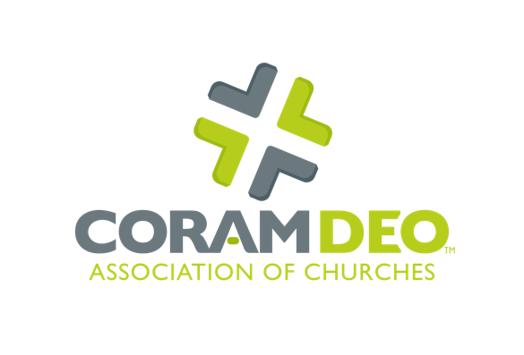
Guide to Identifying Potential Leaders within the Church and Community
Thank you for taking time to prayerfully consider who God may be raising up for gospel ministry within your church and among your family, friends, co-workers and neighbors. We pray that this guide will stimulate your thinking and fuel your excitement for making disciples of Jesus!
Your name:
Church NAME:
Date:

questions to help Identify potential leaders
List the names of individuals in your congregation and community in which you see possible Holy Spirit gifting and calling into ministry:
Identify those in your congregation and community who are already serving as leaders and who may be helped by additional training/preparation for ministry:
Ask each of your ministry team leaders to generate a list of people who serve in their area, whom they think might benefit from leadership training. Help them prayerfully discern which persons from that list they will invite to engage in greater discipleship as a leader. They can then approach that person and say, “This is how I see God at work in you. Would you consider entering a mentoring relationship with me, so that we can help you explore and develop your call as a leader in this area of ministry?”
Prayerfully consider the nature and extent of your church’s ministry in obedience to Scripture and in response to the needs of the local community and the world. Make a list of all the ministries and mission partnerships you are currently engaged in, as well as ones you feel the Lord calling you to engage in the future:
Who in your congregation or among your missional partnerships has the potential gifting, time and desire to be part of each of these ministries? This list should include those currently serving as well as those with potential interest:
List people you know who naturally engage in acts of mercy, service and outreach throughout the course of their weekly life:
Make a list of those you know who are natural self-starters, who always have a new idea, or who love to get new things off the ground:
Who are the people in your congregation/community that provide stability and tend to speak and act from a calm, prayerful heart:
Ask those engaged in youth ministry to list the young people who seem to have a deeper sense of engagement with Christ and a heart for the kingdom of God. These are your potential next-generation leaders:
What support systems (financial, mentoring, communication, awareness, etc.) have you developed or can you develop to help emerging leaders receive their training?
Is your congregation committed to a kingdom view of raising leaders, such that if you have a person in your congregation who feels led to start a new church or missional community, you would be willing and able to embrace that vision and send them forth with your blessing and support? Or would they find resistance from within the church?
Coram Deo Association of Churches is willing to partner with you in active conversations with emerging leaders to assist in equipping and training them. Would you be willing to share the list of names you generated with us?

Questions to Ask Potential Multiplication Leader candidates
Tell us about your relationship with Christ:
Do you affirm the Bible as the Word of God, the only rule of life and faith? Do you believe that Jesus Christ is the only way of salvation?
In what ways have you seen the Holy Spirit work in and through you in your life? How have you been gifted by the Holy Spirit? What fruit has the Spirit caused to grow in your life (cf. Galatians 5:22-23)?
What do you sense the Lord is calling you to do in ministry/the church in this next season of your life?
When have you had a leader or peer affirm a gifting in you or tell you that they could see God working in you in a specific way?
In what context do you find yourself most naturally energized to engage in sharing the gospel, serving others or teaching others?
Is there a ministry or missional activity that you have a vision or passion for that no one else has started yet at your church?
Read 1 Timothy 3:1-13 and Titus 1:5-9. If you are an elder or deacon or are considering being ordained to one of those offices, spend some time in honest reflection before the Lord to determine if you meet these qualifications. If not, who in your church could mentor you and walk alongside you, as you grow into these qualifications?
What role does prayer play in your life and ministry? How have you seen God work through prayer?
Do you feel that you could sustain a balance of work, family life and a deeper engagement in ministry leadership (including studying, taking classes, meeting with a mentor and taking on more responsibilities in church or in a ministry within the community)? What in your life would need to change for you to do this well?
Would you be in a place financially to invest in your training, along with possible financial assistance from your church and/or denomination?
Do you feel that you would be able to affirm the essential tenets of your denomination and to teach others accordingly in their daily walk?
Are you willing to be accountable to the leadership of this church and to submit yourself to encouragement, exhortation and discipline, should the need arise?
List your past ministry, work and educational experiences that you feel have prepared you for taking this next step in ministry leadership.

Please return this form to:
Coram Deo Association of Churches
291 W. Lakewood Blvd. #4
Holland, MI 49424

Or via email to:
jim@coramdeoassociation.org
miguel@coramdeoassociation.org

